The Friends of Hackney Archives present:
Hoxton Hall
Opened 1863 as Music Hall becomes
Temperance mission Quaker school
Neighborhood resource Performance space
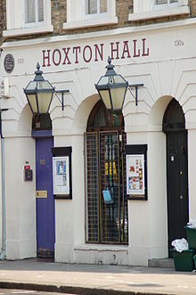
closed by the police
saved by the community

Patrice Lawrence
award winning author, will tell the story

December 7th 6.30pm
Hackney Archives
CLR James Library
Dalston Lane
E8 3BQ
All welcome, free talk
Patrice's latest book Orangeboy - a novel for young adults, was published by Hodder on 2nd June 2016. Her other books include Granny Ting Ting; & Wild Papa Woods.

Her Blog: The Lawrence Line, about writing, selling writing and the family stories that inspire writing http://patricelawrence.wordpress.com/

www.hackneyhistory.org

