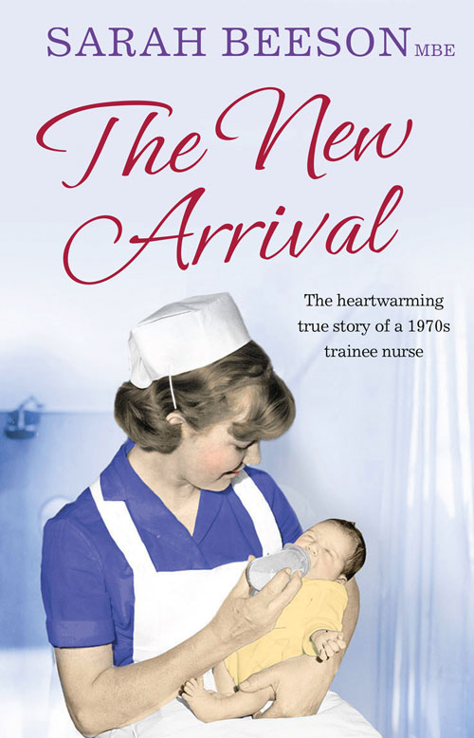
TALK

Sarah Beeson MBE

will speak on

The New Arrival:
memories of nursing in 1970s Hackney

Hackney Archives

on

Wednesday 30th September

6.00pm Refreshments
6.30pm Talk

Friends of Hackney Archives Talk at Dalston CLR James Library and
Hackney Archives, Dalston Square, London E8 3BQ

Over four decades as a nurse and a health visitor Sarah Beeson’s career has been shaped by the needs of children. Since her earliest days on the wards of Hackney Hospital she has stood up for her patients as shown in The New Arrival her heartwarming true story of training to be a nurse in 1970s London.

As an experienced health visitor Sarah has spoken out about the downgrading of the health visiting service and the NHS in the UK and the consequence that is having for families everywhere. Sarah now works with her daughter, writer Amy Beeson, and this mother-daughter writing team regularly contribute information on parenting, child development and health as well as sharing tales of Sarah’s nursing days.

Sarah Beeson’s second memoir about being a newly qualified health visiting in rural Kent in 1970s `She’s Arrived!' will be published by HarperCollins in 2016. http://sarahbeeson.org

If you would like to attend this event, please book your place with Hackney Archives
Department (020 8356 8925 or email archives@hackney.gov.uk)
